**Neon Juan Measurements**

**Models are not to scale**

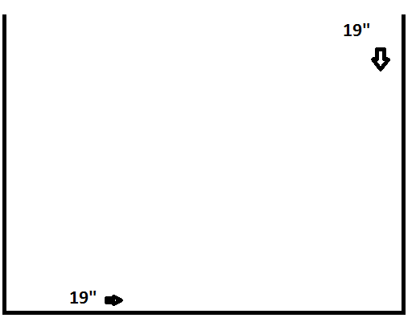

(Based off of arcade cabinent in the webb)

Neon Juan stage is going to be 18.5 inches wide and 18.5 tall. The .5 inches will be off the ground so it won’t look like he is falling through the ground when he and others walk.

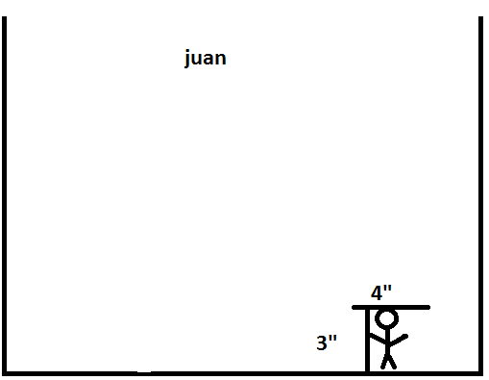

Juan is 4” inches high and 3” inches wide.

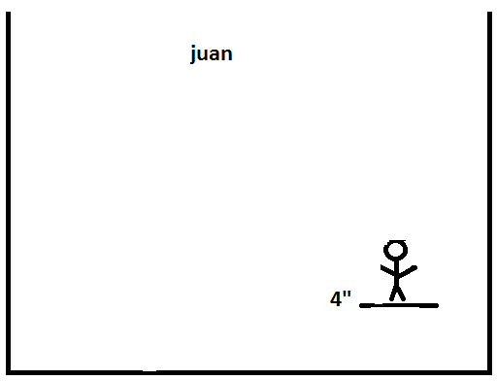

Juan jumps from his foot where his foot is. The height of his jump is 4 inches. So his jump is 4 inches up.

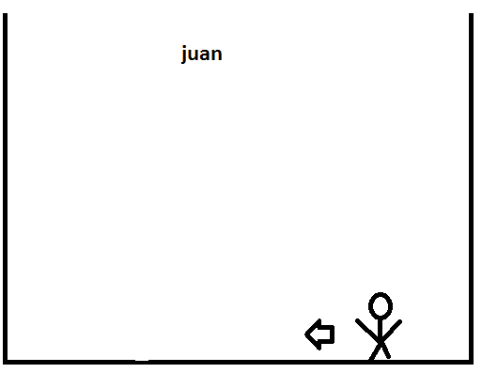

Juan moves for reference from one point and if you move the joystick for 2 seconds he will move 3 inches when he moves for longer than 4 seconds he start dashing which makes him moves 2 seconds in that mode 5 inches